Associational Effects: R Code

Esther Lyon Delsordo

February 28, 2019

This is the beginning of an ongoing project I am conducting in the lab of Dr. Phil Hahn at the University of Montana. Throughout this semester, I am working on entering more data points, making more plots, and interpreting the plots I have already made. The goal is to study the effect of climate on associational effects in polycultures. Herbivore damage refers to damage to the crop by herbivores and enemy damage refers to damage to herbivores by enemies.

Research question: Do polycultures (i.e., planting non-crop plants with crop plants) reduce herbivory on *Brassicae oleracea* and other cruciferous crops more in warmer, dryer climates?

Hypothesis: I predict that increased enemy damage and decreased herbivore damage will be found in warmer, dryer climates.

Summary of methods: Using a recent meta-analysis from Letourneau et al (2011), I extracted latitude and longitude from the site of each study that focuses on cruciferous vegetables. Then I loaded GIS maps with climate data, extracted climate data at coordinates at the site of each study, plotted the values for herbivore damage and enemy abundance for each site with respect to bioclimPC (a climate variable gradient). Below is an example of the R code I used for this project.

## Load Packages

library(tidyverse)  
library(raster)  
library(rgdal)  
library(rgeos)  
library(ggplot2)  
library(RColorBrewer)  
library(viridis)

## Load Bioclim Raster Files

memory.limit(size=12000)

## [1] 12000

mat1 <- raster("wc2.0_bio_2.5m_01.tif")  
mdr2 <- raster("wc2.0_bio_2.5m_02.tif")  
iso3 <- raster("wc2.0_bio_2.5m_03.tif")  
tsd4 <- raster("wc2.0_bio_2.5m_04.tif")  
tmx5 <- raster("wc2.0_bio_2.5m_05.tif")  
tmn6 <- raster("wc2.0_bio_2.5m_06.tif")  
tar7 <- raster("wc2.0_bio_2.5m_07.tif")  
twtq8 <- raster("wc2.0_bio_2.5m_08.tif")  
tdrq9 <- raster("wc2.0_bio_2.5m_09.tif")  
twrq10 <- raster("wc2.0_bio_2.5m_10.tif")  
tcdq11 <- raster("wc2.0_bio_2.5m_11.tif")  
map12 <- raster("wc2.0_bio_2.5m_12.tif")  
pmx13 <- raster("wc2.0_bio_2.5m_13.tif")  
pmn14 <- raster("wc2.0_bio_2.5m_14.tif")  
psd15 <- raster("wc2.0_bio_2.5m_15.tif")  
pwtq16 <- raster("wc2.0_bio_2.5m_16.tif")  
pdrq17 <- raster("wc2.0_bio_2.5m_17.tif")  
pwrq18 <- raster("wc2.0_bio_2.5m_18.tif")  
pcdq19 <- raster("wc2.0_bio_2.5m_19.tif")

## Stack Raster Files

mtStack1 <- stack(mat1,mdr2,iso3,tsd4,tmx5,tmn6,tar7,twtq8,tdrq9,twrq10,  
 tcdq11,map12,pmx13,pmn14,psd15,pwtq16,pdrq17,pwrq18,  
 pcdq19)  
mtStack1$tempSD <- mtStack1$wc2.0_bio_2.5m_04/10  
  
bounds1 <- readOGR(dsn=getwd(), layer= "TM_WORLD_BORDERS_SIMPL-0.3")

## OGR data source with driver: ESRI Shapefile   
## Source: "C:\Users\lyond\Documents\R\EtherGIS", layer: "TM_WORLD_BORDERS_SIMPL-0.3"  
## with 246 features  
## It has 11 fields  
## Integer64 fields read as strings: POP2005

b1 <-read_csv("Coordinates.csv")  
pnts <- cbind(b1$Long,b1$Lat)

## Plot Sites

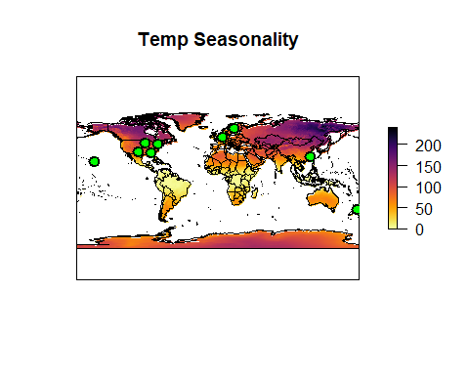plot(mtStack1$tempSD, axes=F, xaxt='n',yaxt='n', main="Temp Seasonality",  
 col=rev(inferno(256)))  
plot(bounds1, add=TRUE, col.axis="white")  
  
points(pnts, pch=21, col="black", bg="green", cex=1.5, lwd=2)

*Fig. 1. Standard deviation of monthly average temperature in degrees C*

## Load Data for Scatterplots

bioclims <- as.data.frame(extract(mtStack1, pnts), header=TRUE)  
  
cabbage_sites <- cbind(b1,bioclims)  
#write.csv(cabbage_sites,"cabbage_sites.csv")

## Make Scatterplots

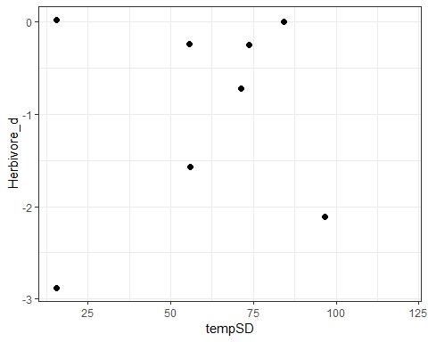ggplot(data=cabbage_sites, aes(x=tempSD, y=Herbivore_d))+  
 geom_point(size=2)+theme_bw()

Fig. 2. Effect of temperature standard deviation on herbivore damage.

ggplot(data=cabbage_sites, aes(x=tempSD, y=Enemy_d))+  
 geom_point(size=2)+theme_bw()+geom_smooth(method = "lm")

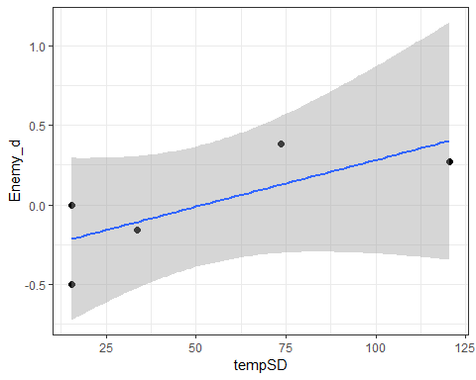

Fig. 3. Effect of temperature standard deviation on enemy damage.

##mat  
ggplot(data=cabbage_sites, aes(x=wc2.0_bio_2.5m_01, y=Herbivore_d))+  
 geom_point(size=2)+theme_bw()

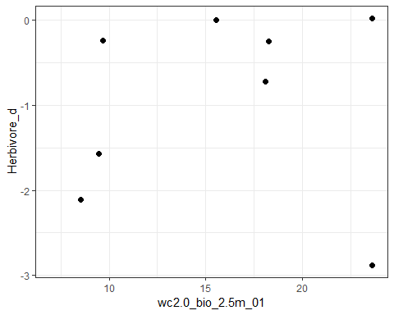

Fig. 4. Effect of mean annual temperature on herbivore damage.